

**Information Technology Institute**

**Assiut Branch**

**Data Visualization Track – Intake 2**

**Team members**

Rahma Yasser

Ereny Naem

Kerolos Romany

Ahmed Saad

# Real Estate Analytical Project Documentation

## Project Introduction

**Project Overview:**

The Real Estate Analytics Platform is designed to centralize, integrate, and analyze data related to property listings, customer leads, sales transactions, agent performance, and marketing campaigns. The platform aims to provide actionable insights that enable property companies or brokerages to optimize decision-making, improve marketing efficiency, and increase lead-to-sale conversion rates.

**Business Goals:**

**Centralized Data Repository:** Integrate data from multiple sources such as ,property listing platforms (e.g., PropertyFinder), sales records, and marketing campaign data into a single data warehouse.

**Enhanced Business Intelligence**: Provide interactive dashboards and reporting tools for management to visualize key metrics, trends, and relationships between agents, properties, leads, and campaigns.

**Performance Monitoring:** Track agent productivity, property sales, lead conversion rates, and marketing ROI to identify strengths and areas for improvement.

**Data-Driven Decision Making:** Enable executives and analysts to make informed decisions using historical and current data, forecasting trends, and predicting property demand.

**Operational Efficiency:** Automate data extraction, cleaning, and transformation (ETL) processes to ensure data accuracy, consistency, and timeliness.

## Data Sources

## ****2.1 Overview****

The data used in this project was collected from a combination of web scraping, public datasets, and simulated (dummy) data to support the analysis of real estate sales, leads, and agent performance.

## ****2.2 Source Datasets****

**Description:**

Contains all information about available properties, including property type, size, city, neighborhood, price, listing status (active, sold, rented), and other attributes.

**Source:**

**Collection Method: Web Scraping:** For public platforms.

**1. Property Finder Egypt**This platform provides detailed property listings across Egypt, including:

* Property type, location, and price  
  Data was scraped using automated tools to extract structured information for analysis.

**2. Fastbase – Egypt Real Estate Agencies Index**This source offers a directory of real estate agencies operating in Egypt. It was used to:

* Identify active agencies
* Analyze geographic distribution
* Cross-reference agent performance with listings

**3. Kaggle Public Datasets**

Kaggle was used to supplement the project with:

* Historical property sales data
* Lead generation datasets
* Agent performance metrics  
  These datasets helped validate models and simulate real-world scenarios.

**4. Dummy Data**

Custom-generated data was used to:

* Simulate missing fields or enrich scraped data
* Test system performance and dashboard functionality
* Ensure consistency in data structure for modeling

1. **Data Transformations**

### ****3.1 Data Cleaning****

In this stage, we focused on preparing the raw real-estate data for reliable analysis. Our process included:

* **Removing duplicate rows** to avoid repeated leads, customers, or listings.
* **Handling missing values** by imputing logical defaults or removing unusable records.
* **Standardizing formats** for dates, phone numbers, emails, currency, and text fields.
* **Fixing inconsistent categories** in lead status, campaign type, and locations.
* **Validating business keys** for customers, agents, campaigns, and properties.
* **Correcting outliers** in price, commission, and sales records to maintain accuracy.
* **Resolving mismatched IDs** between leads, listings, and agents across all tables.
* **Dropping unnecessary columns** that do not contribute to analysis.
* **Renaming columns clearly** for better readability and consistency.

## 4. Modeling & Statistical Analysis – DB & DWH

## ****4.1 SSIS****

The Dimensional Model for the Real Estate Analytics project is designed as a Star Schema to facilitate analysis in Power BI or any other BI tool.

The model focuses on Fact Tables to measure events (Sales, Leads) and Dimension Tables to provide analytical properties (Leads, Agents, Reviews, Date, Campaigns, listings).

* 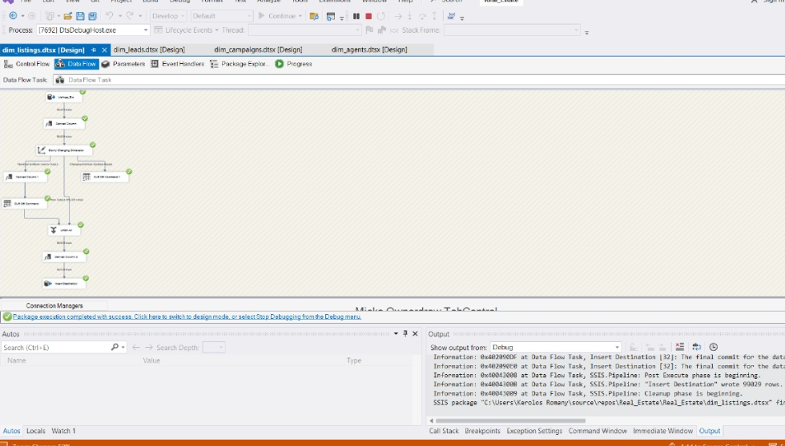Dim listing
* 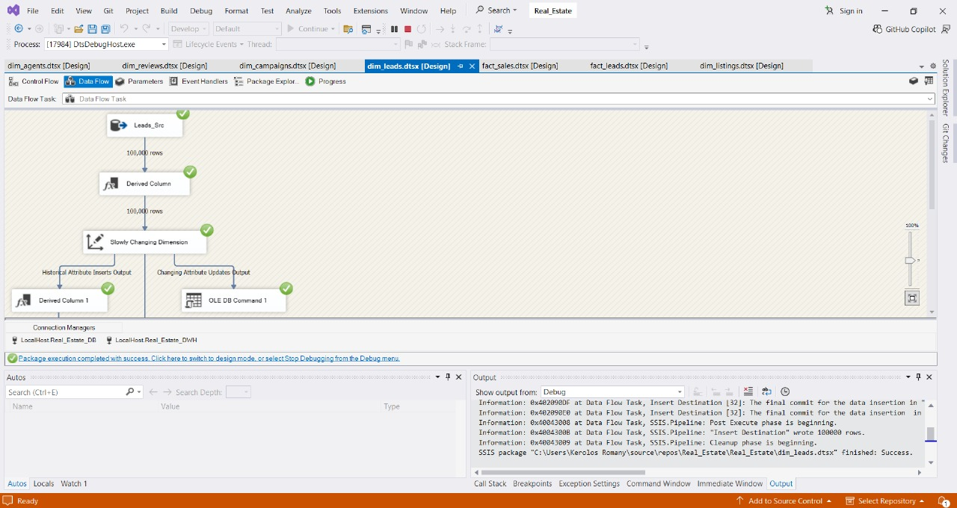Dim leads

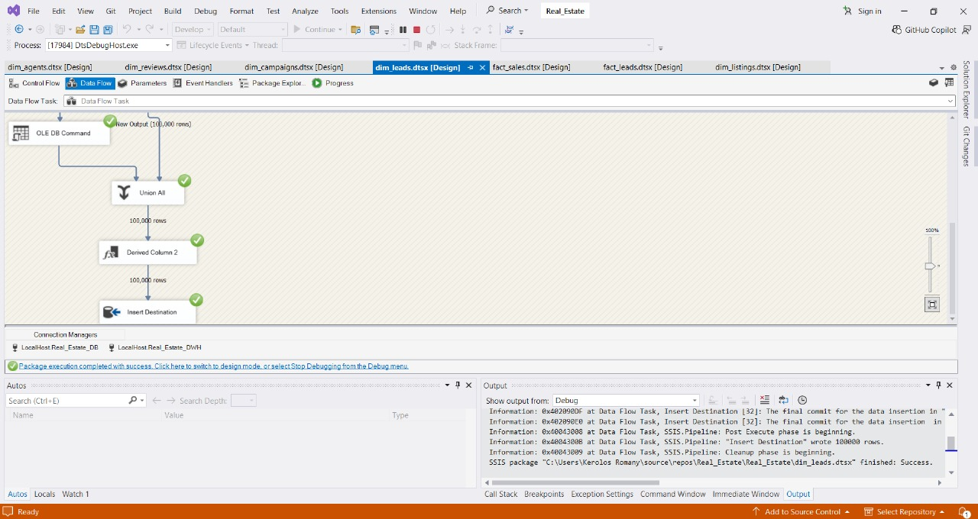

* Dim Campaigns

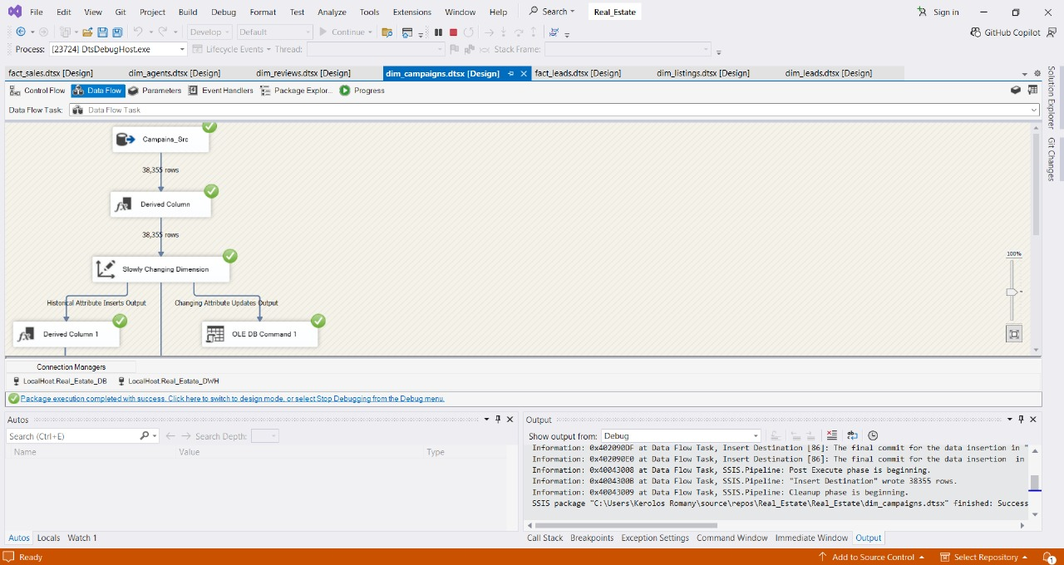

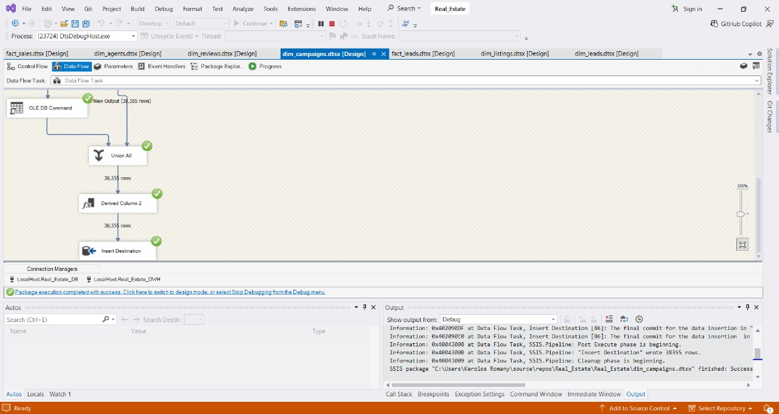

* Dim agents

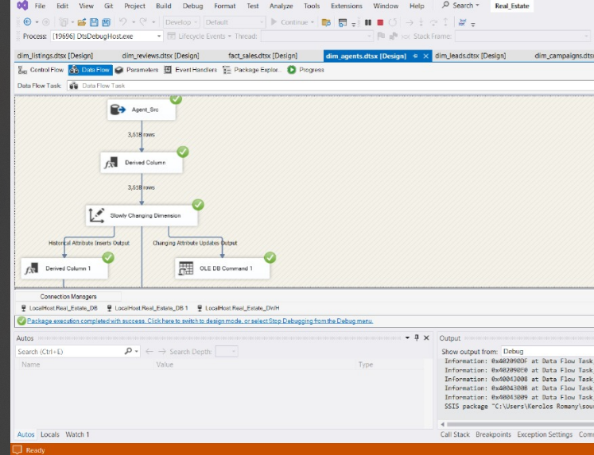

* Fact Sales

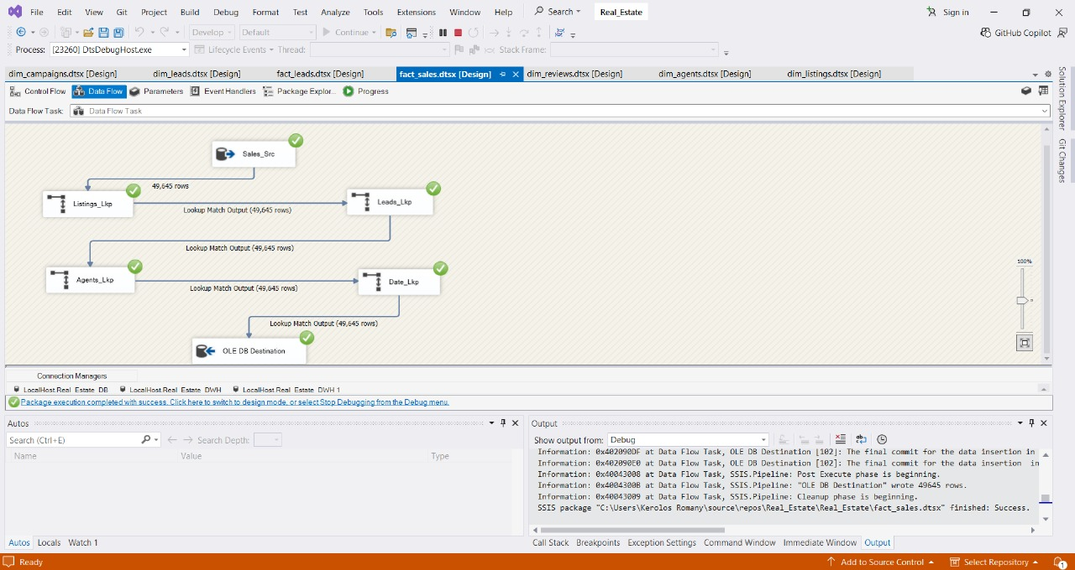

* Fact leads

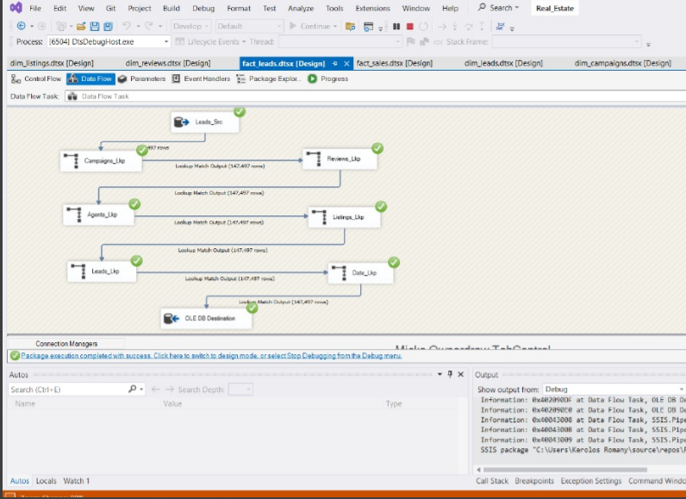

* Dim Reviews

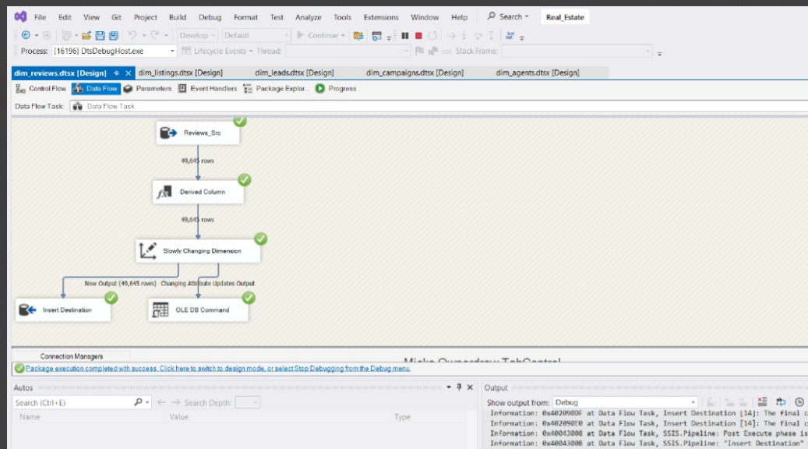

* 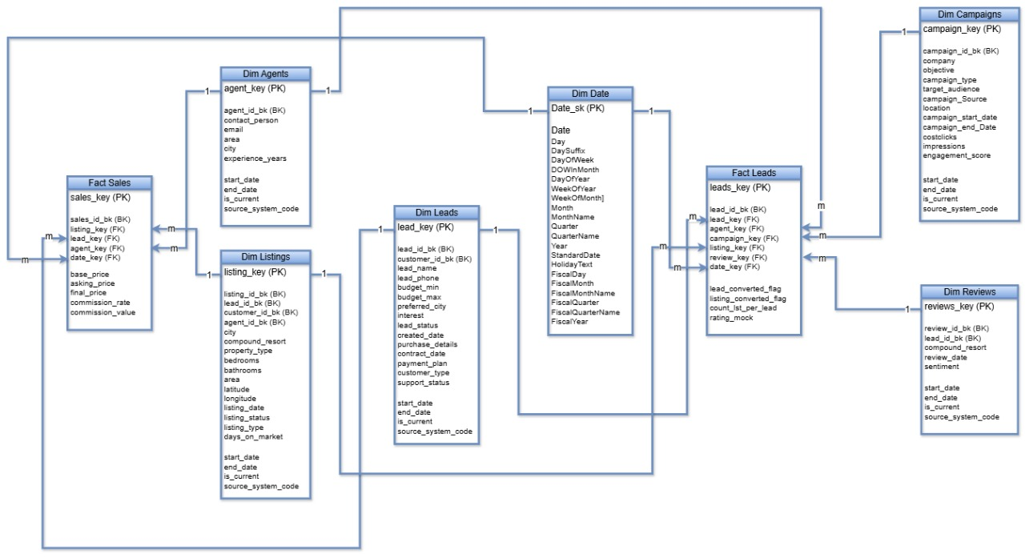**Relationships**

## 4.2 BI Queries

*-- Shows top-performing agents by total sales and revenue.*

SELECT

a.agent_id,

a.company_name,

COUNT(s.sale_id) AS total_sales,

SUM(s.sold_price) AS total_revenue,

AVG(s.commission_rate) AS avg_commission_rate,

SUM(s.commission_value) AS total_commission_earned

FROM Agents a

LEFT JOIN Sales s ON a.agent_id = s.agent_id

GROUP BY a.agent_id, a.company_name

ORDER BY total_revenue , total_sales DESC;

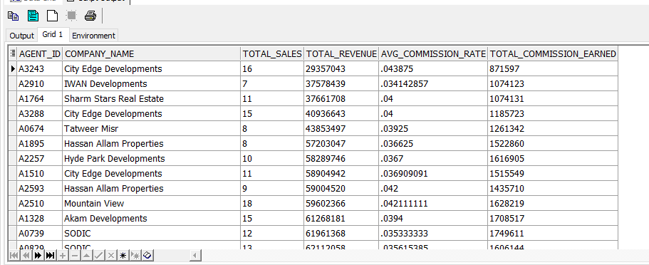

* Insight *The most common campaign objectives*

*SELECT Objective, COUNT(*) AS Total_Campaigns*

*FROM marketing_campaign*

*GROUP BY Objective*

*ORDER BY Total_Campaigns DESC;*

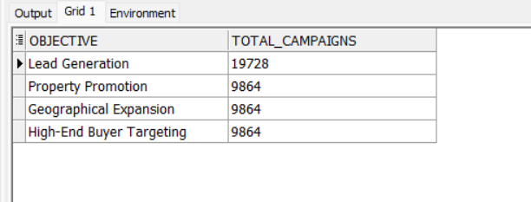

* Insight: The number of leads (Leads) for each agent is calculated according to their status (Hot, Warm, Cold), and the agents are arranged in descending order according to the number of "hot" customers‎"

SELECT

a.Agent_ID,

COUNT(CASE WHEN l.Lead_Status = 'Hot' THEN 1 END) AS HotLeads,

COUNT(CASE WHEN l.Lead_Status = 'Warm' THEN 1 END) AS WarmLeads,

COUNT(CASE WHEN l.Lead_Status = 'Cold' THEN 1 END) AS ColdLeads

FROM Agents a

JOIN Leads l ON a.Agent_ID = l.Agent_ID

GROUP BY a.Agent_ID

ORDER BY HotLeads DESC;

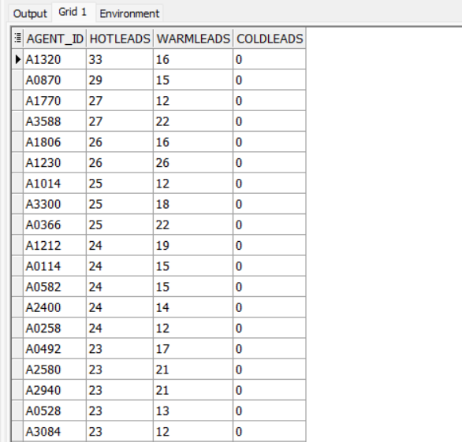

-- Insight *Filter campaigns by target audience and source*

SELECT campaign_id, Company_name, Objective, Engagement_Score

FROM marketing_campaign

WHERE Target_Audience = 'Women 25-34'

AND Campaign_Source = 'Instagram';

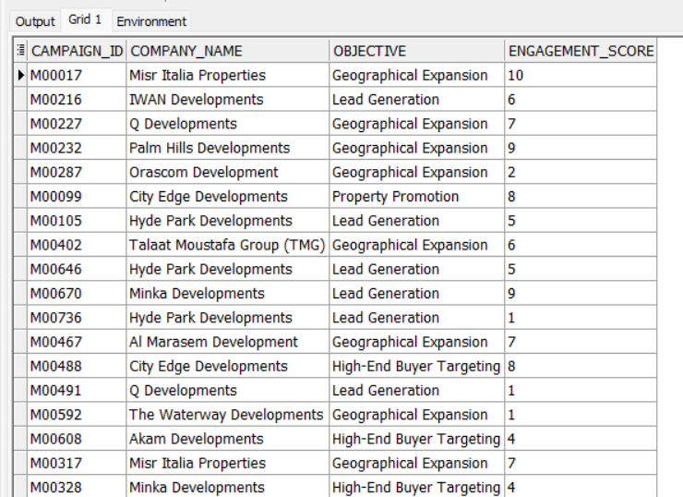

--‎ Insight Displays the top 5 agents from a table in order of years of experience from highest to lowest‎

SELECT *

FROM (

SELECT * FROM Agents ORDER BY EXPERIENCE_YEARS DESC

)

WHERE ROWNUM <= 5;

*--‎* Insight: *Number of Agents in Each City‎*

SELECT city, COUNT(*) AS agent_count

FROM Agents

GROUP BY city

ORDER BY agent_count DESC;

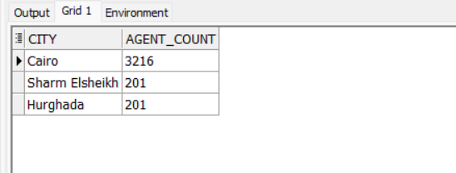

*--‎* Insight Top *5 Agents by Total Commission‎*

SELECT agent_id, total_commission

FROM (

SELECT agent_id, SUM(commission_value) AS total_commission

FROM Sales

GROUP BY agent_id

ORDER BY total_commission DESC

)

WHERE ROWNUM <= 5;

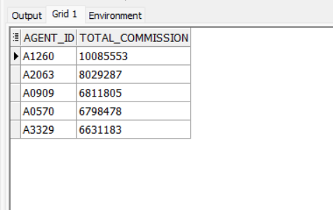

*--* Insight *‎Number of properties by property type‎*

SELECT property_type, COUNT(*) AS total_listings

FROM Listings

GROUP BY property_type

ORDER BY total_listings DESC;

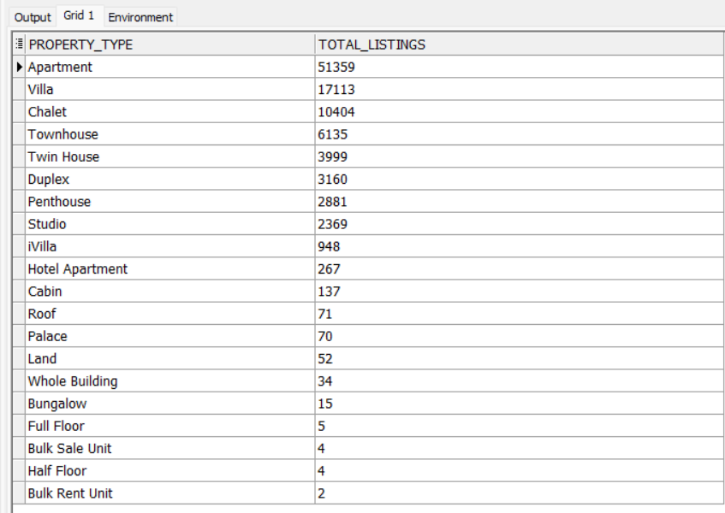

*--‎* Insight *Average price required by property type*

SELECT property_type, AVG(asking_price) AS avg_asking_price

FROM Listings

GROUP BY property_type

ORDER BY avg_asking_price DESC;

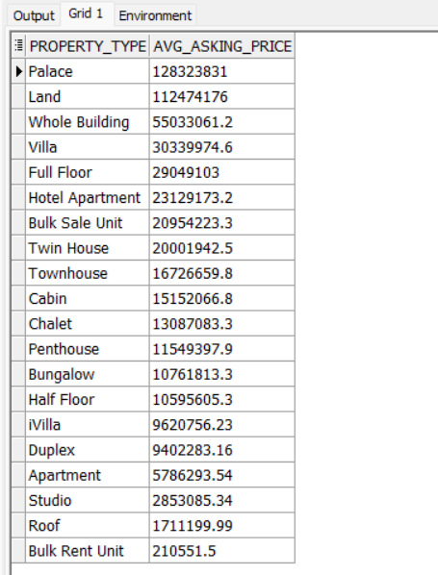

*--‎* Insight *Total sales by city‎*

SELECT l.city, COUNT(*) AS total_sales

FROM Sales s

JOIN Listings l ON s.listing_id = l.listing_id

GROUP BY l.city

ORDER BY total_sales DESC;

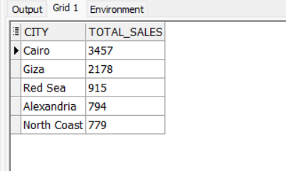

‎ -- InsightAgent Performance by Number of Sales‎

SELECT agent_id, COUNT(*) AS sales_count

FROM Sales

GROUP BY agent_id

ORDER BY sales_count DESC;

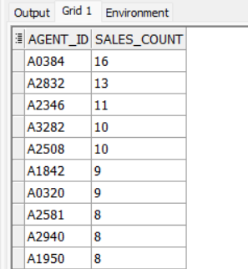

*--‎* *Insight Average commission percentage per agent‎*

SELECT agent_id, AVG(commission_rate) AS avg_rate

FROM Sales

GROUP BY agent_id

ORDER BY avg_rate DESC;

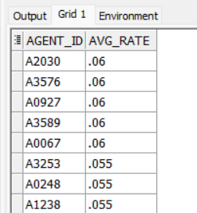

*-- Insight ‎Properties that have stayed the longest on the market‎*

SELECT listing_id, days_on_market

FROM Listings

WHERE days_on_market IS NOT NULL

ORDER BY days_on_market DESC;

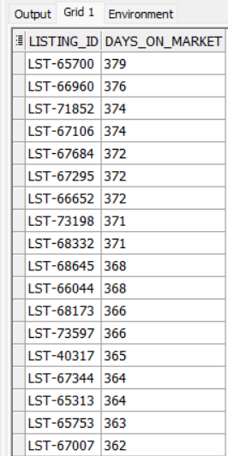

*-- Insight ‎The most common type of property in each city‎*

SELECT city, property_type, COUNT(*) AS count

FROM Listings

GROUP BY city, property_type

ORDER BY city, count DESC;

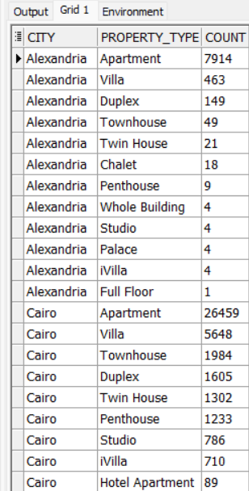

*--‎ Insight Total revenue per agent‎*

SELECT agent_id, SUM(sold_price) AS total_revenue

FROM Sales

GROUP BY agent_id

ORDER BY total_revenue DESC;

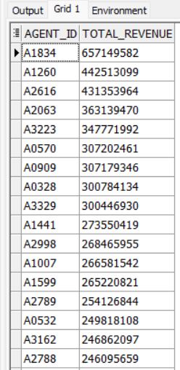

*-- Insight ‎Average final price by property type‎*

SELECT property_type, AVG(final_price) AS avg_final_price

FROM Listings

GROUP BY property_type

ORDER BY avg_final_price DESC;

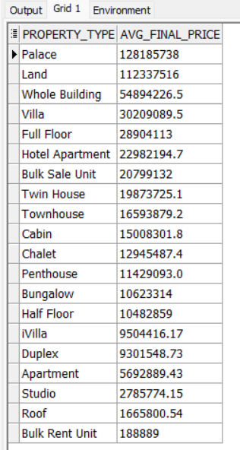

*--‎ Insight Number of properties sold per agent‎*

SELECT agent_id, COUNT(*) AS sold_count

FROM Listings

WHERE listing_status = 'Sold'

GROUP BY agent_id

ORDER BY sold_count DESC;

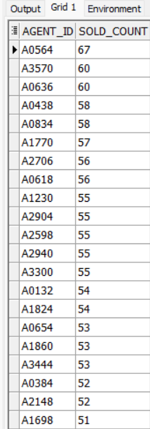

*--‎Most Compounds/Resorts by Number of Listed Properties‎*

SELECT compound_resort, COUNT(*) AS listing_count

FROM Listings

GROUP BY compound_resort

ORDER BY listing_count DESC;

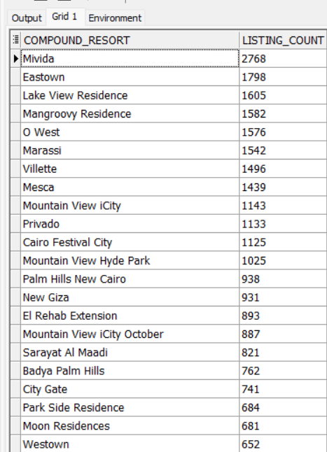

*--‎* Insight *Number of leads per case‎*

SELECT

Lead_Status,

COUNT(*) AS LeadCount

FROM Leads

GROUP BY Lead_Status

ORDER BY LeadCount DESC;

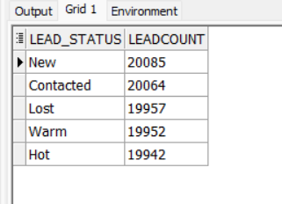

*-- Insight ‎Agents with more than 10 "Hot" leads‎*

SELECT

a.Agent_ID,

COUNT(l.Lead_ID) AS HotLeadCount

FROM Agents a

JOIN Leads l ON a.Agent_ID = l.Agent_ID

WHERE l.Lead_Status = 'Hot'

GROUP BY a.Agent_ID

HAVING COUNT(l.Lead_ID) > 10

ORDER BY HotLeadCount DESC;

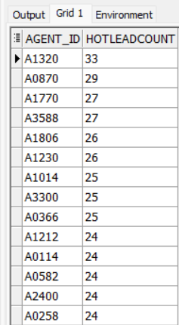

*--‎Agents who have not made any sales‎*

SELECT a.Agent_ID, a.Contact_Person

FROM Agents a

LEFT JOIN Sales s ON a.Agent_ID = s.Agent_ID

WHERE s.Sale_ID IS NULL;

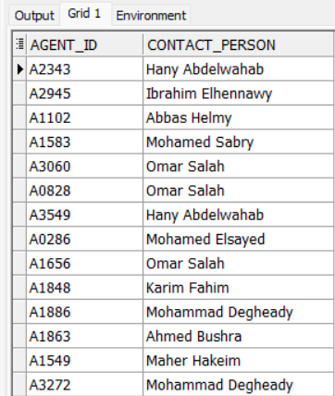

*-- #I Insight: Helps identify which property types sell fastest and for how much.*

SELECT

property_type,

AVG(asking_price) AS avg_asking_price,

AVG(final_price) AS avg_final_price,

AVG(days_on_market) AS avg_days_on_market

FROM Listings

GROUP BY property_type

ORDER BY avg_final_price DESC;

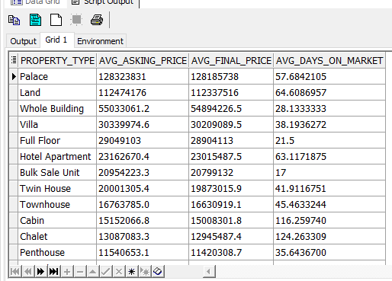

*--Insight: Geographic Performance by City*

SELECT

l.city,

COUNT(s.sale_id) AS total_sales,

SUM(s.sold_price) AS total_revenue,

AVG(s.commission_value) AS avg_commission,

COUNT(DISTINCT l.listing_id) AS total_listings

FROM Sales s

JOIN Listings l ON s.listing_id = l.listing_id

JOIN Agents a ON s.agent_id = a.agent_id

GROUP BY l.city

ORDER BY total_revenue DESC;

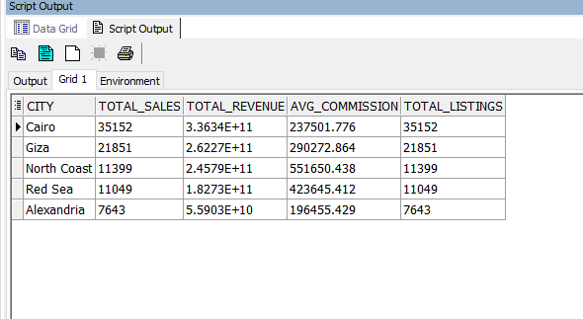

*--Insight: Repeat Customers*

SELECT

c.customer_id,

c.name,

COUNT(s.sale_id) AS total_purchases,

SUM(s.sold_price) AS total_spent,

AVG(s.sold_price) AS avg_purchase_value,

Max(s.sale_date) AS sale_date,

MIN(l.LISTING_date) AS listing_date

FROM Customers c

JOIN Sales s

ON c.customer_id = s.customer_id

JOIN Listings l

ON s.listing_id = l.listing_id

GROUP BY c.customer_id, c.name

HAVING COUNT(s.sale_id) > 1

ORDER BY total_purchases DESC;

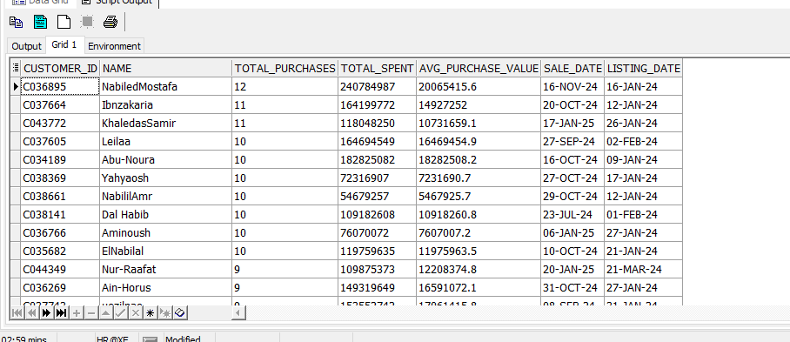

*-- City × Agent × Loyal Customers Insight*

WITH loyal_customers AS (

SELECT c.customer_id

FROM Customers c

JOIN Sales s ON c.customer_id = s.customer_id

GROUP BY c.customer_id

HAVING COUNT(s.sale_id) > 1

)

SELECT

a.city,

a.agent_id,

a.COMPANY_NAME AS COMPANY_NAME,

COUNT(DISTINCT lc.customer_id) AS loyal_customers_count,

COUNT(s.sale_id) AS total_sales_to_loyals,

SUM(s.sold_price) AS total_revenue_from_loyals,

AVG(s.commission_value) AS avg_commission

FROM Sales s

JOIN Agents a ON s.agent_id = a.agent_id

JOIN loyal_customers lc ON s.customer_id = lc.customer_id

GROUP BY a.city, a.agent_id, a.COMPANY_NAME

ORDER BY a.city, total_revenue_from_loyals DESC;

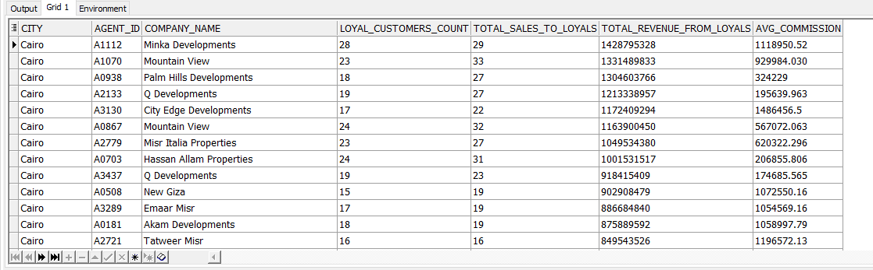

*-- Insight: Top 5 Loyal Customers ()*

SELECT *

FROM (

SELECT

c.customer_id,

c.name,

COUNT(s.sale_id) AS total_purchases,

SUM(s.sold_price) AS total_spent,

AVG(s.sold_price) AS avg_purchase_value,

MAX(s.sale_date) AS last_purchase,

MIN(l.listing_date) AS first_listing_date

FROM Customers c

JOIN Sales s

ON c.customer_id = s.customer_id

JOIN Listings l

ON s.listing_id = l.listing_id

GROUP BY c.customer_id, c.name

HAVING COUNT(s.sale_id) > 1

ORDER BY total_purchases DESC, total_spent DESC

)

WHERE ROWNUM <= 5;

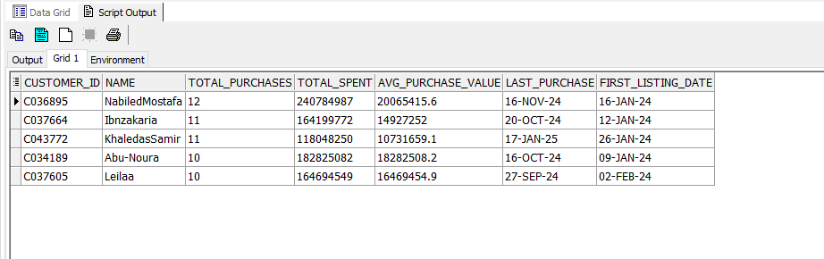

*--Average Waiting Time*

SELECT

c.customer_id,

c.name,

ROUND(AVG(s.sale_date - l.listing_date), 2) AS avg_days_to_purchase

FROM Customers c

JOIN Sales s ON c.customer_id = s.customer_id

JOIN LISTINGS l ON s.listing_id = l.listing_id

GROUP BY c.customer_id, c.name

ORDER BY avg_days_to_purchase;

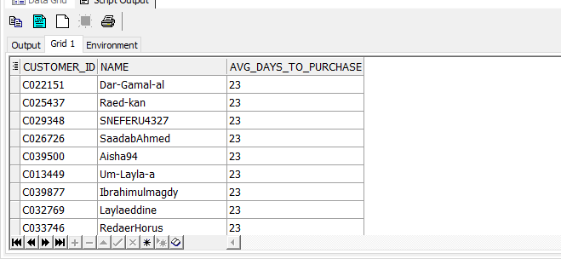

*--Best cities by sales*

SELECT

l.city,

COUNT(s.sale_id) AS total_sales,

AVG(s.sold_price) AS avg_sold_price

FROM Listings l

JOIN Sales s ON l.listing_id = s.listing_id

GROUP BY l.city

ORDER BY total_sales DESC;

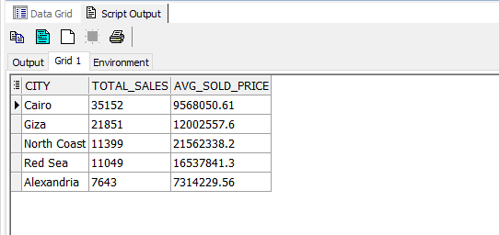

*--Review Sentiment Analysis*

SELECT

COMPOUND_RESORT,

AVG(Rating_mock) AS avg_rating,

SUM(CASE WHEN Sentiment='Positive' THEN 1 ELSE 0 END) AS positive_reviews,

SUM(CASE WHEN Sentiment='Negative' THEN 1 ELSE 0 END) AS negative_reviews,

SUM(CASE WHEN Sentiment='Neutral' THEN 1 ELSE 0 END) AS neutral_reviews,

COUNT(*) AS total_reviews

FROM Reviews

GROUP BY COMPOUND_RESORT

ORDER BY avg_rating DESC;

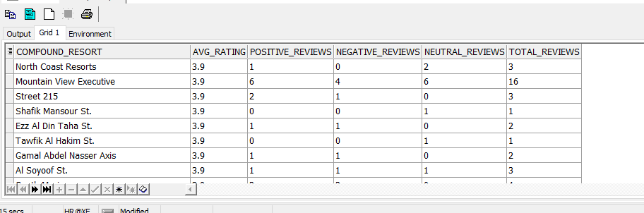

*--Lead Conversion Analysis*

SELECT

lead_status,

COUNT(*) AS total_leads,

SUM(converted_flag) AS converted_leads,

ROUND(SUM(converted_flag) * 100.0 / COUNT(*), 2) AS conversion_rate

FROM Leads

GROUP BY lead_status

ORDER BY conversion_rate DESC;

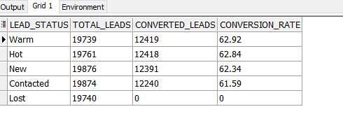

*--Commission vs Speed Correlation*

SELECT

a.agent_id,

a.company_name,

CORR(s.commission_rate, l.days_on_market) AS correlation_commission_speed

FROM Agents a

JOIN Listings l ON a.agent_id = l.agent_id

JOIN Sales s ON l.listing_id = s.listing_id

GROUP BY a.agent_id, a.company_name

ORDER BY correlation_commission_speed ASC;

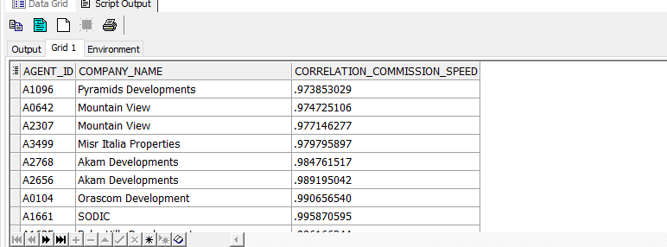

*--Pareto 80/20 – Property Type Revenue*

WITH PropertyRevenue AS (

SELECT

property_type,

SUM(s.sold_price) AS total_revenue

FROM Sales s

JOIN Listings l ON s.listing_id = l.listing_id

GROUP BY property_type

),

Ranked AS (

SELECT

property_type,

total_revenue,

ROUND(100 * SUM(total_revenue) OVER (ORDER BY total_revenue DESC) / SUM(total_revenue) OVER (), 2) AS cumulative_percentage

FROM PropertyRevenue

)

SELECT

property_type,

total_revenue,

cumulative_percentage,

CASE WHEN cumulative_percentage <= 80 THEN 'Top 20% Drivers' ELSE 'Long Tail' END AS category

FROM Ranked;

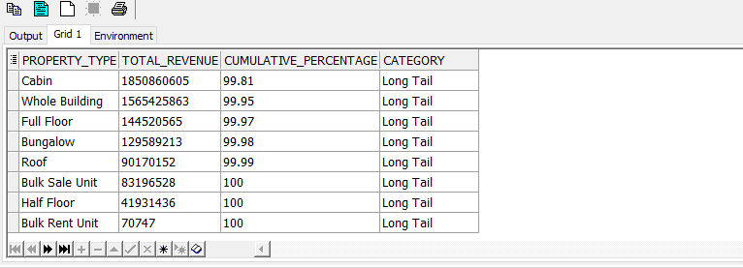

*--Agent Performance Summary*

WITH AgentSales AS (

SELECT

a.agent_id,

a.company_name,

COUNT(s.sale_id) AS Total_Sales,

SUM(s.sold_price) AS Total_Revenue,

AVG(l.days_on_market) AS Avg_Days_On_Market

FROM Agents a

LEFT JOIN Sales s ON a.agent_id = s.agent_id

LEFT JOIN Listings l ON s.listing_id = l.listing_id

GROUP BY a.agent_id, a.company_name

),

AgentLeads AS (

SELECT

agent_id,

COUNT(lead_id) AS Total_Leads,

SUM(converted_flag) AS Leads_Converted,

ROUND(SUM(converted_flag)*100.0/COUNT(lead_id),2) AS Conversion_Rate

FROM Leads

GROUP BY agent_id

)

SELECT

a.agent_id,

a.company_name,

COALESCE(s.Total_Sales,0) AS Total_Sales,

COALESCE(s.Total_Revenue,0) AS Total_Revenue,

COALESCE(s.Avg_Days_On_Market,0) AS Avg_Days_On_Market,

COALESCE(l.Total_Leads,0) AS Total_Leads,

COALESCE(l.Leads_Converted,0) AS Leads_Converted,

COALESCE(l.Conversion_Rate,0) AS Conversion_Rate

FROM Agents a

LEFT JOIN AgentSales s ON a.agent_id = s.agent_id

LEFT JOIN AgentLeads l ON a.agent_id = l.agent_id

ORDER BY Total_Revenue DESC;

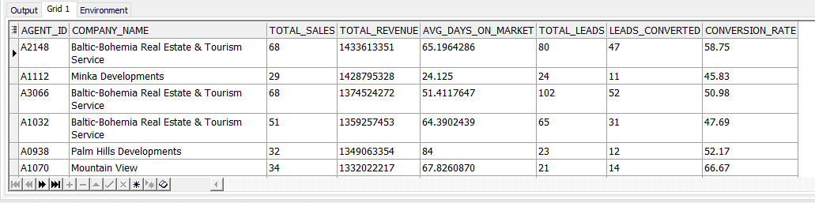

*--City Performance (Top City)*

SELECT

l.city AS City_Name,

COUNT(s.sale_id) AS Total_Sales,

COUNT(DISTINCT l.listing_id) AS Total_Listings,

SUM(s.sold_price) AS Total_Revenue,

ROUND(AVG(s.sold_price), 2) AS Avg_Sold_Price,

ROUND(AVG(l.days_on_market), 2) AS Avg_Days_On_Market

FROM Listings l

LEFT JOIN Sales s ON l.listing_id = s.listing_id

GROUP BY l.city

ORDER BY Total_Revenue DESC;

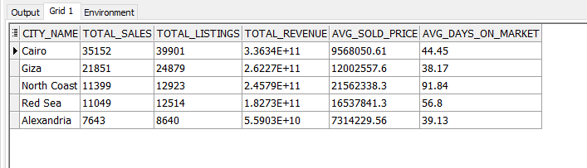

*-------------Sales and revenue trends over time (monthly or quarterly)*

SELECT

TO_CHAR(s.sale_date, 'YYYY-MM') AS Month,

COUNT(s.sale_id) AS Total_Sales,

SUM(s.sold_price) AS Total_Revenue

FROM Sales s

GROUP BY TO_CHAR(s.sale_date, 'YYYY-MM')

ORDER BY Month;

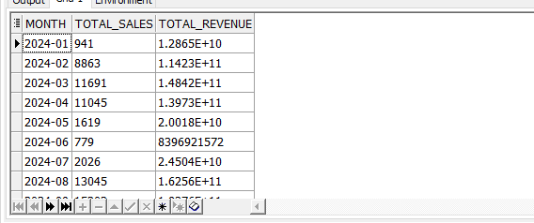

*--Market Insights & Pricing Distribution Helps visualize property pricing ranges per city or type.*

SELECT

l.city,

l.property_type,

ROUND(AVG(s.sold_price), 2) AS Avg_Price,

MIN(s.sold_price) AS Min_Price,

MAX(s.sold_price) AS Max_Price

FROM Listings l

JOIN Sales s ON l.listing_id = s.listing_id

GROUP BY l.city, l.property_type

ORDER BY Avg_Price DESC;

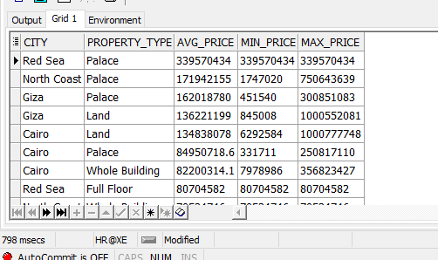

*--Total Leads Generated*

SELECT COUNT(*) AS Total_Leads FROM Leads;

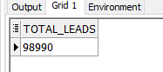

*--Conversion Rate (Leads ? Sales)*

SELECT ROUND(SUM(converted_flag)*100.0/COUNT(*),2) AS Conversion_Rate FROM Leads;

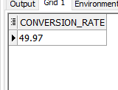

*--Average Property Value Sold*

SELECT ROUND(AVG(sold_price),2) AS Avg_Property_Value FROM Sales;

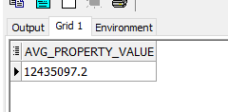

*--Revenue per Agent*

SELECT agent_id, SUM(sold_price) AS Revenue FROM Sales GROUP BY agent_id;

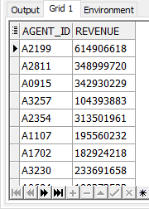

*--Average Sales Cycle Duration*

SELECT ROUND(AVG(s.sale_date - l.listing_date),2) AS Avg_Sales_Cycle FROM Sales s JOIN Listings l ON s.listing_id=l.listing_id;

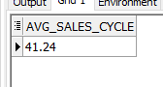

*--Active Listings by Status and Region*

SELECT city, LISTING_STATUS, COUNT(*) FROM Listings GROUP BY city, LISTING_STATUS;

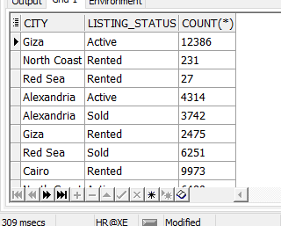

*--Cost per Lead*

SELECT

m.CAMPAIGN_SOURCE AS Lead_Source,

SUM(m.COST) AS Total_Cost,

COUNT(l.LEAD_ID) AS Total_Leads,

ROUND(SUM(m.COST) / NULLIF(COUNT(l.LEAD_ID), 0), 2) AS Cost_Per_Lead

FROM MARKETING_CAMPAIGN m

JOIN LEADS l ON m.CAMPAIGN_ID = l.CAMPAIGN_ID

GROUP BY m.CAMPAIGN_SOURCE

ORDER BY Cost_Per_Lead ASC;

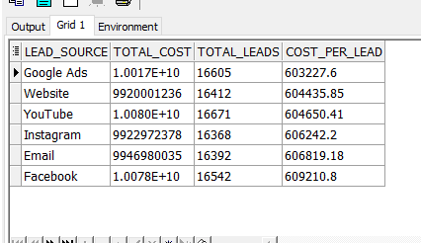

*--Cost_Per_Click,*

SELECT

Campaign_Source,

SUM(Cost) AS Total_Cost,

SUM(Clicks) AS Total_Clicks,

SUM(Engagement_Score) AS Total_Engagement,

ROUND(SUM(Cost) / NULLIF(SUM(Clicks), 0), 2) AS Cost_Per_Click,

ROUND(SUM(Cost) / NULLIF(SUM(Engagement_Score), 0), 2) AS Cost_Per_Engagement

FROM MARKETING_CAMPAIGN

GROUP BY Campaign_Source

ORDER BY Cost_Per_Click ASC;

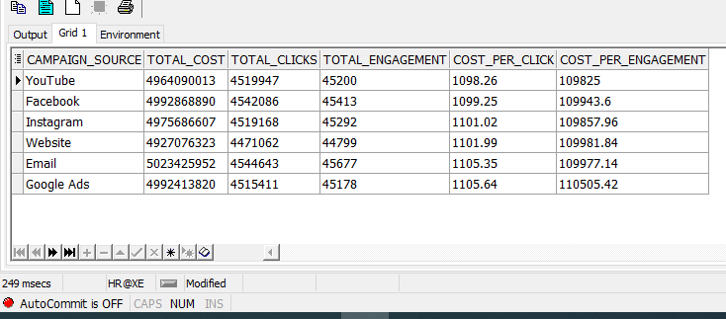

*----------------------Marketing Channel Performance Summary*

SELECT

Campaign_Source,

SUM(Cost) AS Total_Cost,

SUM(Clicks) AS Total_Clicks,

SUM(Impressions) AS Total_Impressions,

SUM(Engagement_Score) AS Total_Engagement,

ROUND(SUM(Cost) / NULLIF(SUM(Clicks), 0), 2) AS Cost_Per_Click,

ROUND(SUM(Cost) / NULLIF(SUM(Engagement_Score), 0), 2) AS Cost_Per_Engagement,

ROUND((SUM(Clicks) / NULLIF(SUM(Impressions), 0)) * 100, 2) AS CTR_Percentage,

ROUND((SUM(Engagement_Score) / NULLIF(SUM(Impressions), 0)) * 100, 2) AS Engagement_Rate_Percentage

FROM MARKETING_CAMPAIGN

GROUP BY Campaign_Source

ORDER BY Cost_Per_Click ASC;

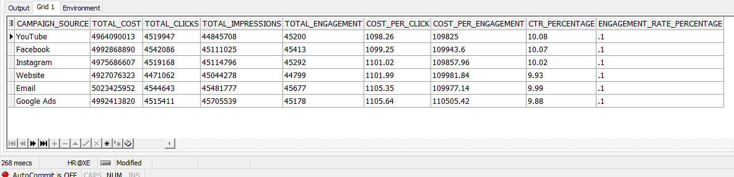

*--Lead Source Effectiveness*

SELECT

m.Campaign_Source AS Lead_Source,

COUNT(l.Lead_ID) AS Total_Leads,

SUM(l.Converted_Flag) AS Converted_Leads,

ROUND(SUM(l.Converted_Flag) * 100.0 / COUNT(l.Lead_ID), 2) AS Conversion_Rate_Percentage,

ROUND(SUM(m.Cost) / NULLIF(SUM(l.Converted_Flag), 0), 2) AS Cost_Per_Converted_Lead

FROM Leads l

JOIN Marketing_Campaign m

ON l.Campaign_ID = m.Campaign_ID

GROUP BY m.Campaign_Source

ORDER BY Conversion_Rate_Percentage DESC;

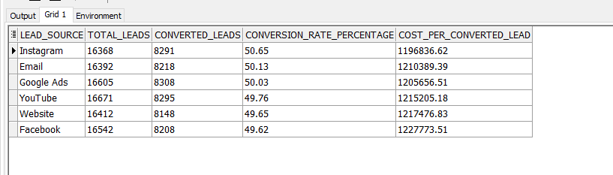

*-------------------------------CREATE TRIGGER------------------------------------------------------------------*

CREATE OR REPLACE TRIGGER trg_sales_update_audit

BEFORE UPDATE ON sales

FOR EACH ROW

BEGIN

INSERT INTO sales_audit (

audit_id,

sale_id,

old_sold_price,

old_commission_rate,

old_commission_value,

modified_date,

modified_by

)

VALUES (

sales_audit_seq.NEXTVAL,

:OLD.sale_id,

:OLD.sold_price,

:OLD.commission_rate,

:OLD.commission_value,

SYSDATE,

USER

);

END;

/

UPDATE sales

SET sold_price = sold_price + 1000

WHERE sale_id = 'S000001';

SELECT * FROM sales_audit

ORDER BY audit_id DESC;

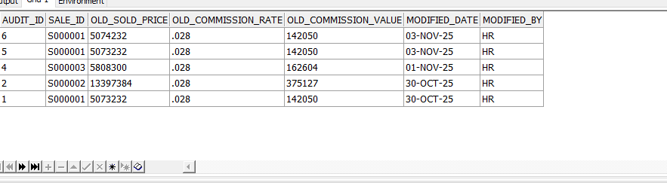

*--------------------------------CREATE PACKAGE------------------------------------------------------*

CREATE OR REPLACE PACKAGE RealEstate_Pkg AS

PROCEDURE Show_Top_Agents(p_top_n IN NUMBER DEFAULT 5);

PROCEDURE Campaign_Performance(p_top_n IN NUMBER DEFAULT 5);

PROCEDURE Customer_Summary;

END RealEstate_Pkg;

/

CREATE OR REPLACE PACKAGE BODY RealEstate_Pkg AS

*-- Show top Agents by sales*

PROCEDURE Show_Top_Agents(p_top_n IN NUMBER DEFAULT 5) IS

BEGIN

FOR rec IN (

SELECT * FROM (

SELECT

a.agent_id,

COUNT(s.sale_id) AS total_sales,

SUM(s.sold_price) AS total_revenue,

ROUND(SUM(s.sold_price)/COUNT(s.sale_id),2) AS avg_sale,

ROW_NUMBER() OVER (ORDER BY SUM(s.sold_price) DESC) AS rn

FROM sales s

JOIN listings l ON s.listing_id = l.listing_id

JOIN agents a ON s.agent_id = a.agent_id

GROUP BY a.agent_id

)

WHERE rn <= p_top_n

) LOOP

***DBMS_OUTPUT.PUT_LINE***(

'Agent: ' || rec.agent_id ||

' | Sales: ' || rec.total_sales ||

' | Revenue: ' || rec.total_revenue ||

' | Avg Sale: ' || rec.avg_sale

);

END LOOP;

END Show_Top_Agents;

*-------------------------------CREATE PROCEDURES------------------------------------------------------------*

*-- Marketing campaign performance*

PROCEDURE Campaign_Performance(p_top_n IN NUMBER DEFAULT 5) IS

BEGIN

FOR rec IN (

SELECT * FROM (

SELECT

c.campaign_id,

c.company_name,

c.location,

ROUND((c.clicks / NULLIF(c.impressions, 0)) * 100, 2) AS ctr_percent,

ROUND(c.engagement_score, 2) AS engagement_score,

ROW_NUMBER() OVER (ORDER BY c.engagement_score DESC) AS rn

FROM marketing_campaign c

)

WHERE rn <= p_top_n

) LOOP

***DBMS_OUTPUT.PUT_LINE***(

'Campaign: ' || rec.campaign_id ||

' | Company: ' || rec.company_name ||

' | Location: ' || rec.location ||

' | CTR: ' || rec.ctr_percent || '%' ||

' | Engagement: ' || rec.engagement_score

);

END LOOP;

END Campaign_Performance;

PROCEDURE Customer_Summary IS

BEGIN

FOR rec IN (

SELECT

customer_type,

COUNT(*) AS total_customers,

SUM(CASE WHEN support_status = 'Active' THEN 1 ELSE 0 END) AS active_customers

FROM customers

GROUP BY customer_type

) LOOP

***DBMS_OUTPUT.PUT_LINE***(

'Customer Type: ' || rec.customer_type ||

' | Total: ' || rec.total_customers ||

' | Active: ' || rec.active_customers

);

END LOOP;

END Customer_Summary;

END RealEstate_Pkg;

/

SHOW ERRORS;

SET SERVEROUTPUT ON;

EXEC RealEstate_Pkg.Show_Top_Agents;

EXEC RealEstate_Pkg.Campaign_Performance;

EXEC RealEstate_Pkg.Customer_Summary;

## 

## Dashboard

## overview

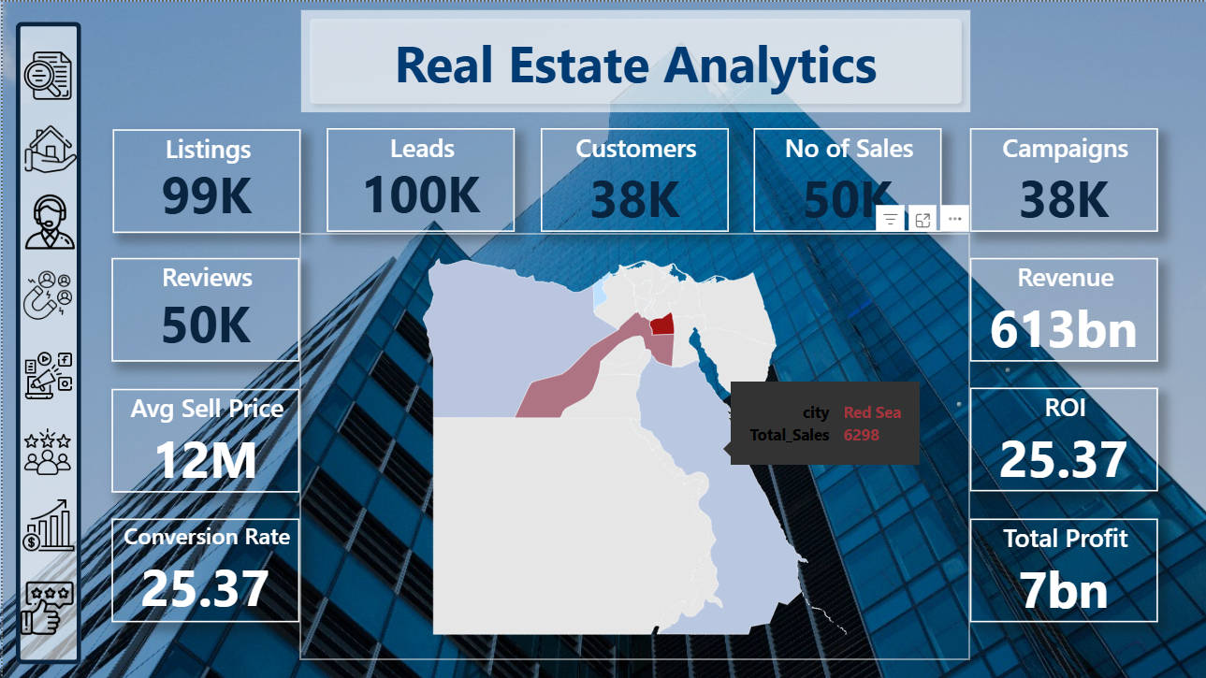

* 1. **Listings**

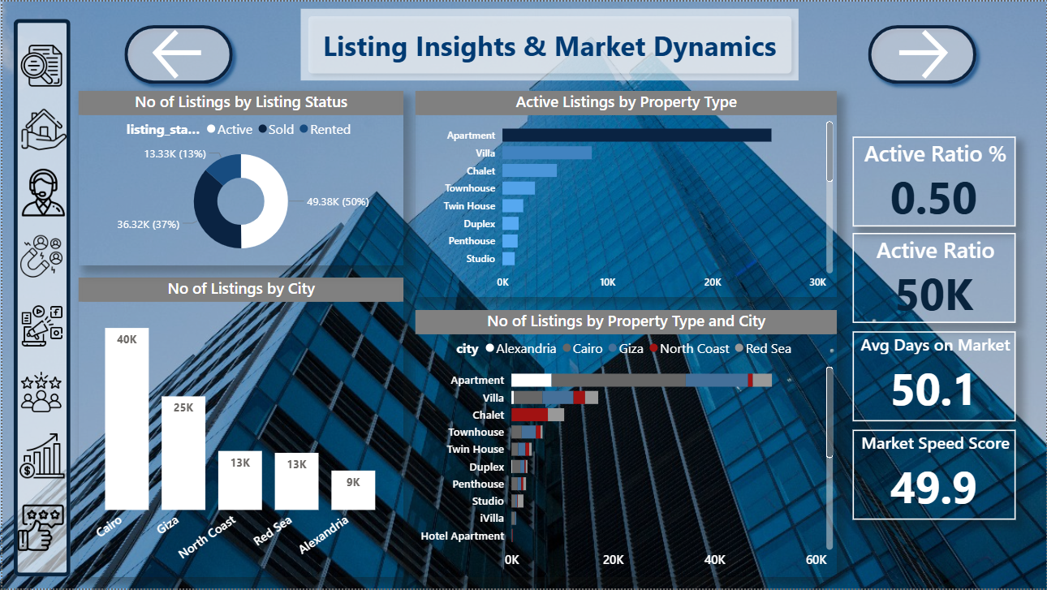

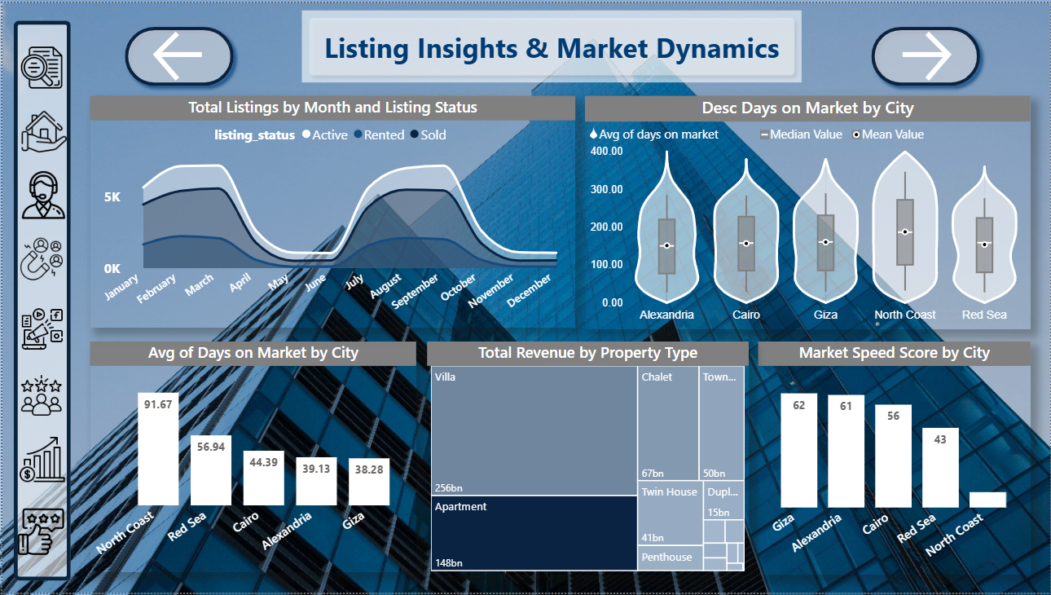

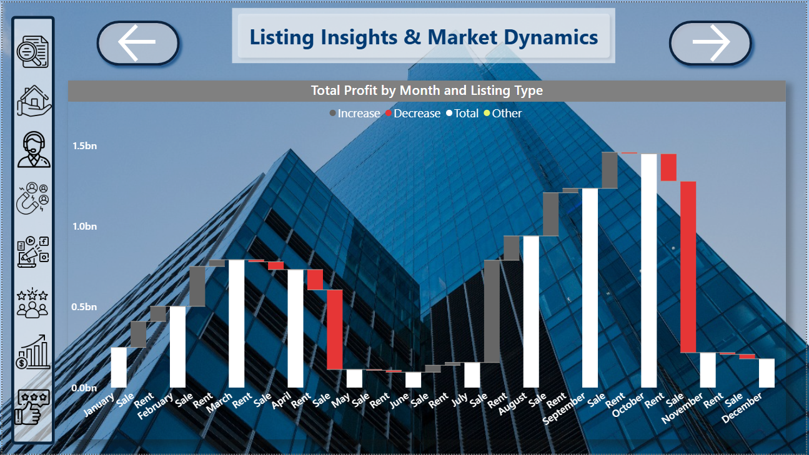

* 1. **Agents**

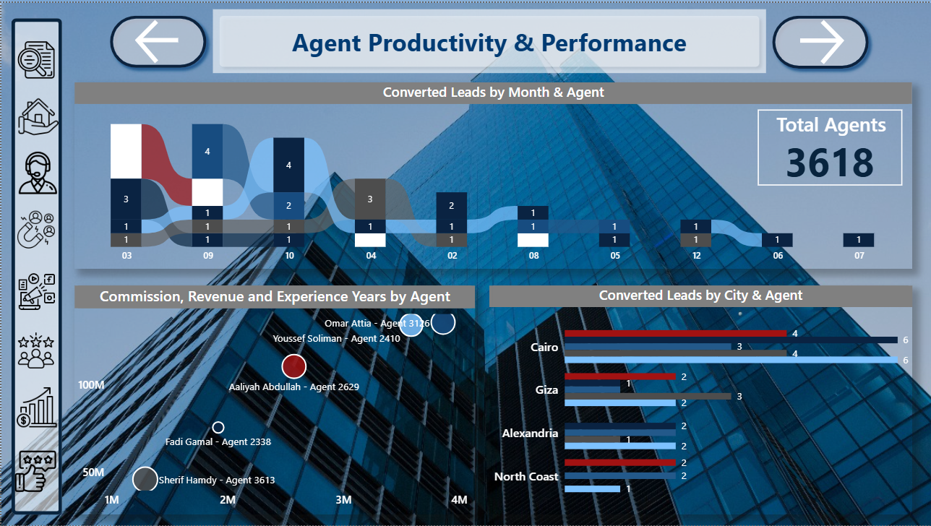

* 1. **Leads**

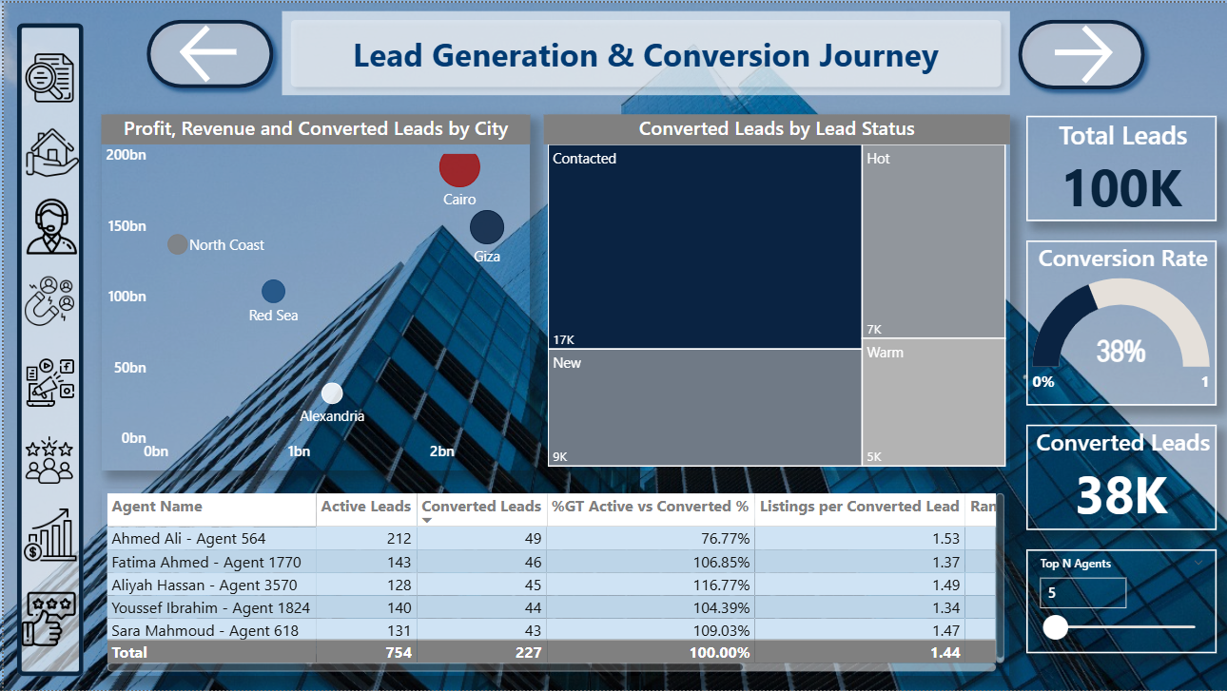

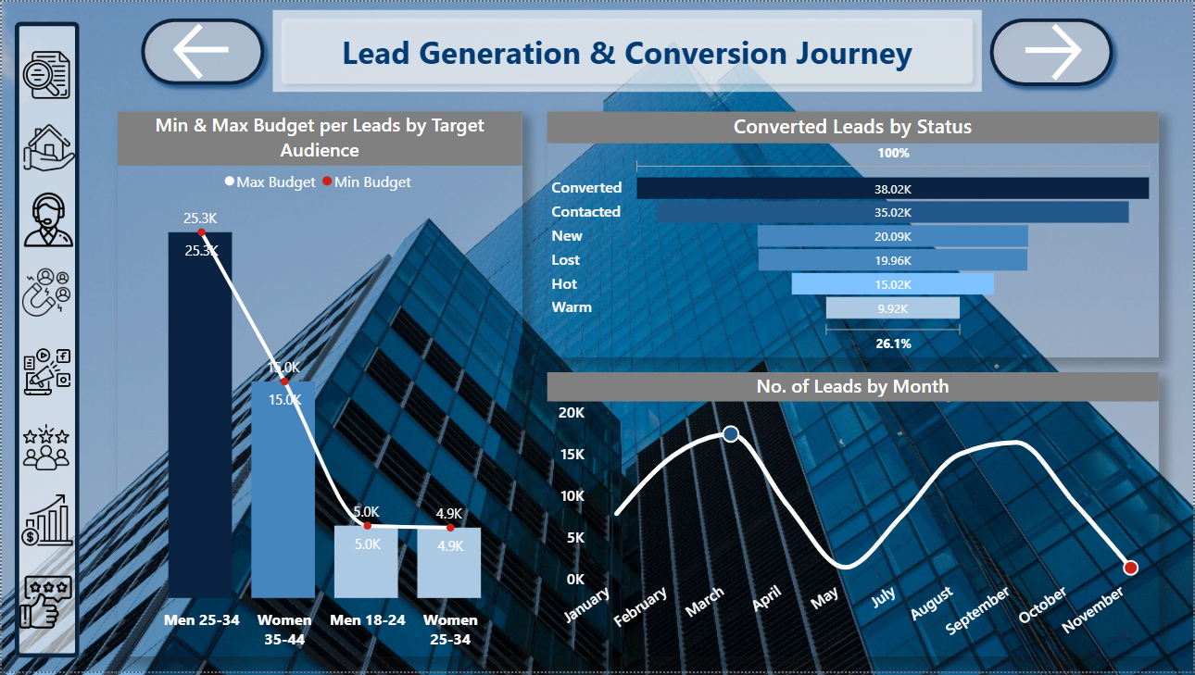

* 1. **Campaigns**

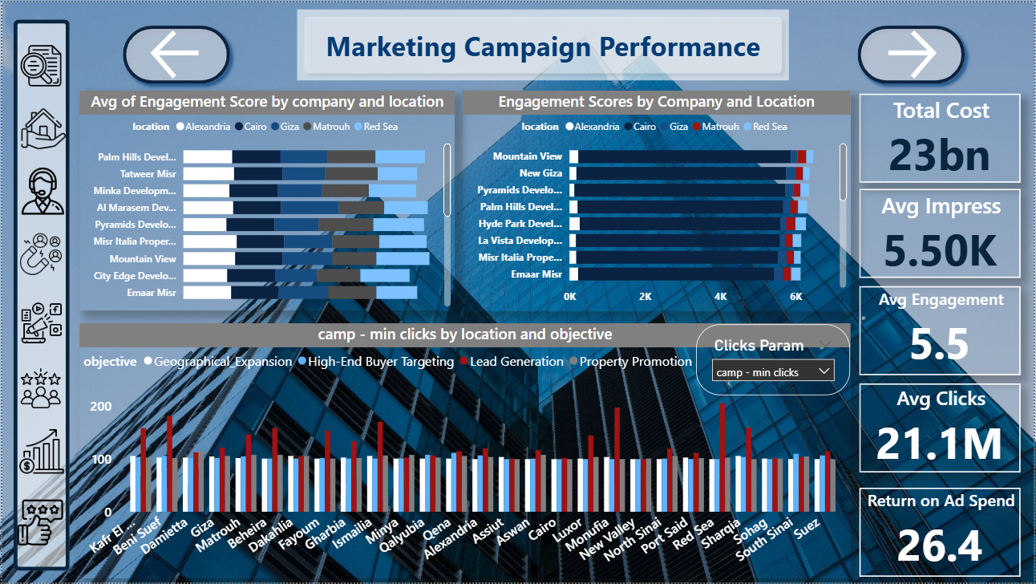

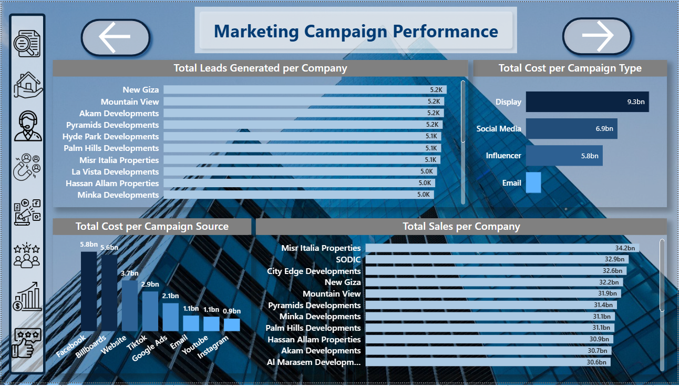

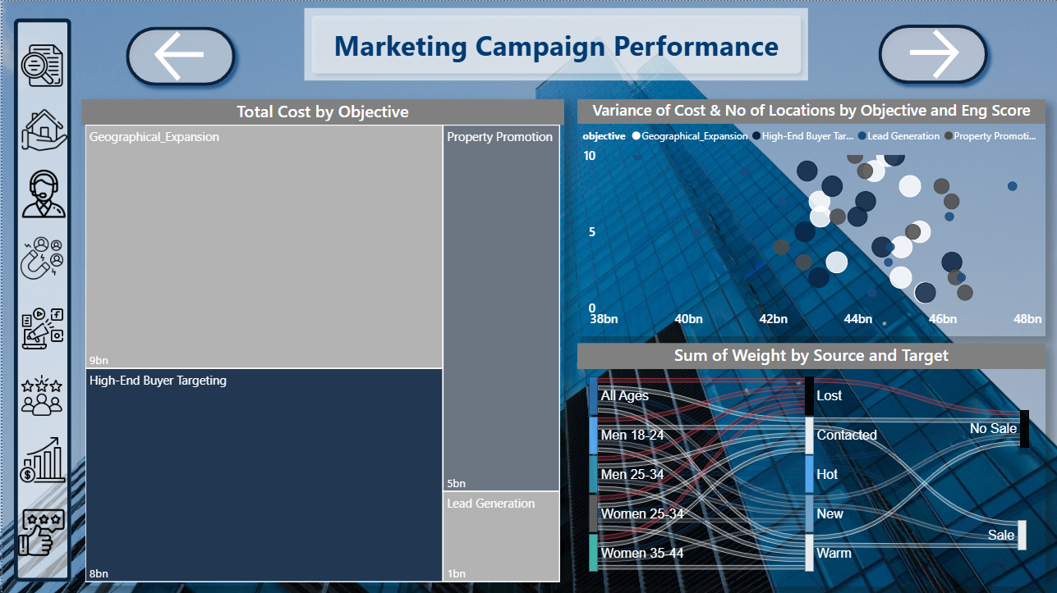

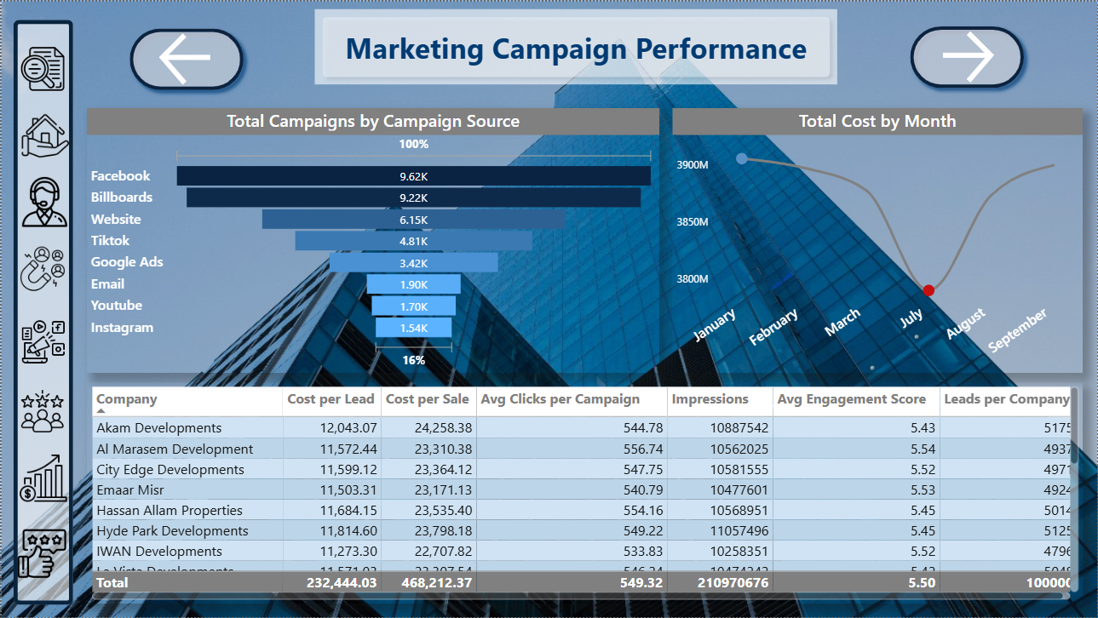

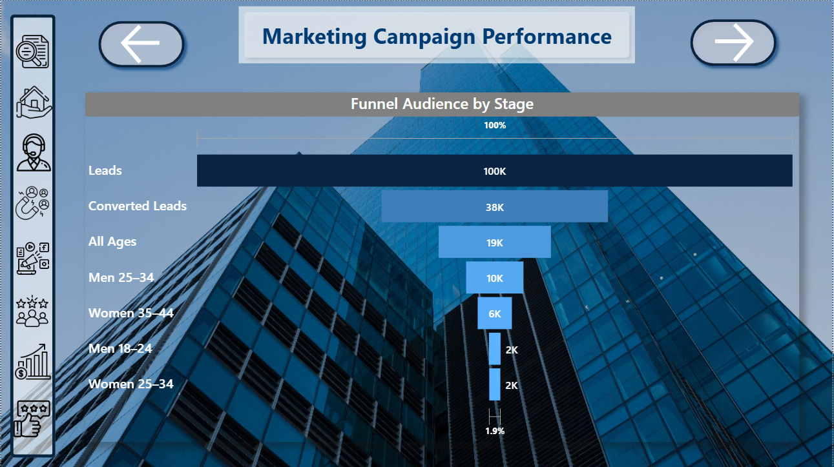

* 1. **Customers**

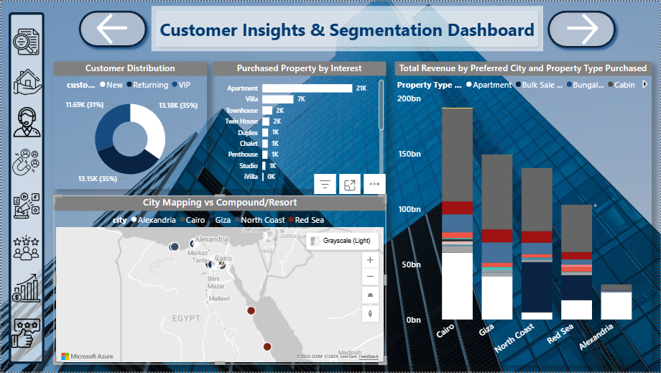

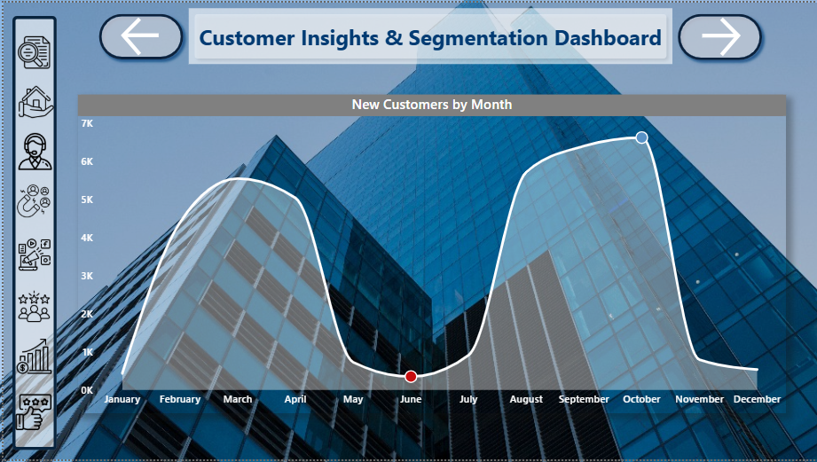

* 1. **Sales**

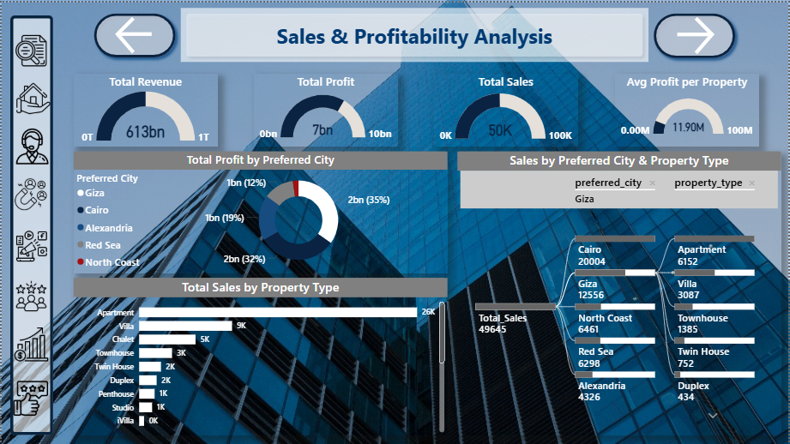

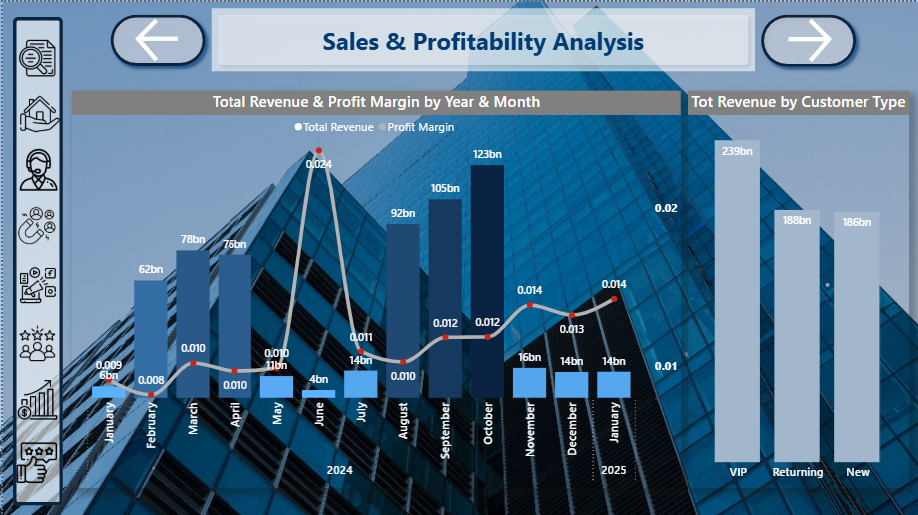

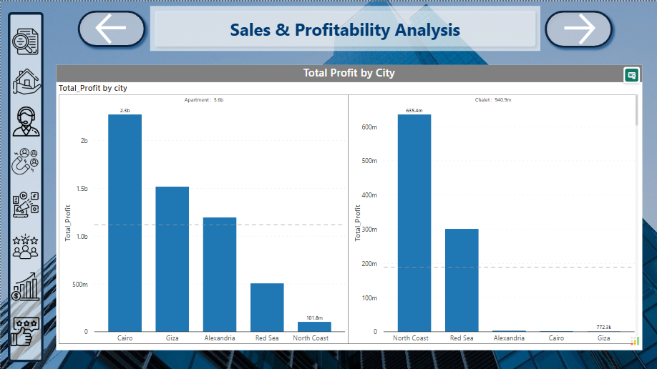

* 1. **Reviews**

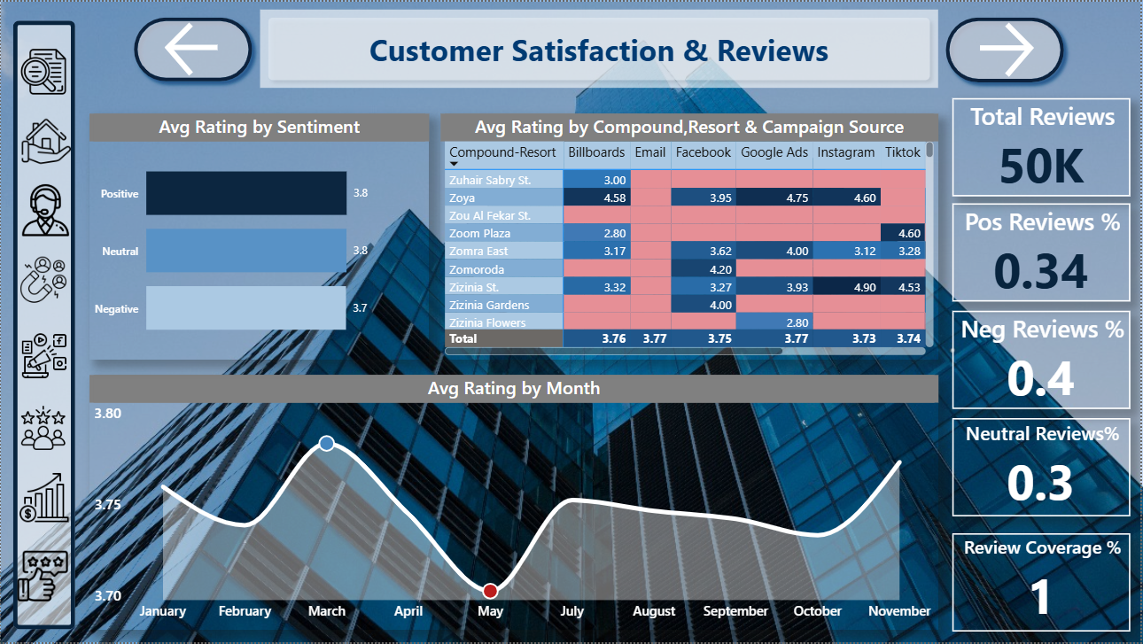

## Appendices

Scraping Code

**Property Finder - Properties:**

from bs4 import BeautifulSoup

import pandas as pd

from selenium import webdriver

import time

import re

houses_data = []

driver = webdriver.Chrome()

for i in range(1, 300):

    url = f'https://www.propertyfinder.eg/en/search?l=2254&c=1&fu=0&ob=mr&page={i}'

    driver.get(url)

    time.sleep(5)

    soup = BeautifulSoup(driver.page_source, 'html.parser')

    houses = soup.find_all('li', attrs={'data-testid': True})

    if not houses:

        print(f"No houses found on page {i}")

        continue

    for house in houses:

        try:

            # Price

            price_tag = house.find('p', class_=re.compile('price'))

            price = price_tag.text.strip() if price_tag else 'N/A'

            # Location

            location_tag = house.find('p', class_=re.compile('location'))

            location = location_tag.text.strip() if location_tag else 'N/A'

            # Property Type

            property_type_tag = house.find('p', class_=re.compile('property-type'))

            property_type = property_type_tag.text.strip() if property_type_tag else 'N/A'

            # Listed Since

            time_listed_tag = house.find('p', class_=re.compile('publish-info'))

            time_listed = time_listed_tag.text.strip() if time_listed_tag else 'N/A'

            # Bedrooms, Bathrooms, Area

            details_tags = house.find_all('p', class_=re.compile('details-item'))

            bedrooms = details_tags[0].text.strip() if len(details_tags) > 0 else 'N/A'

            bathrooms = details_tags[1].text.strip() if len(details_tags) > 1 else 'N/A'

            area = details_tags[2].text.strip() if len(details_tags) > 2 else 'N/A'

            houses_data.append({

                'Price': price,

                'Location': location,

                'Property Type': property_type,

                'Bedrooms': bedrooms,

                'Bathrooms': bathrooms,

                'Area': area,

                'Listed Since': time_listed

            })

        except Exception as e:

            print(f"Error on page {i}: {e}")

            continue

driver.quit()

# Save data to CSV

df = pd.DataFrame(houses_data)

df.to_csv('property_fider_data.csv', index=False, encoding='utf-8-sig')

print("Data has been scraped and saved to property_finder_data.csv")

**Fastbase – Agents:**

# pip install selenium beautifulsoup4 pandas tqdm openpyxl

from selenium import webdriver

from selenium.webdriver.chrome.service import Service

from selenium.webdriver.chrome.options import Options

from bs4 import BeautifulSoup

from tqdm import tqdm

import pandas as pd

import time

chrome_options = Options()

chrome_options.add_argument("--headless")

chrome_options.add_argument("--no-sandbox")

chrome_options.add_argument("--disable-dev-shm-usage")

driver = webdriver.Chrome(options=chrome_options)

countries = ["Egypt", "Saudi-Arabia", "United-Arab-Emirates"]

pages = 50

all_data = []

print(" Fetching data from FastBase using Selenium...")

for country in countries:

    base_url = f"https://www.fastbase.com/countryindex/{country}/R/Real-estate-agency"

    print(f"\n Fetching: {country}")

    for page in tqdm(range(1, pages + 1), desc=f"{country}"):

        url = f"{base_url}?page={page}"

        driver.get(url)

        time.sleep(7)

        soup = BeautifulSoup(driver.page_source, "html.parser")

        rows = soup.select("table.table tbody tr")

        for row in rows:

            name = row.select_one(".td_cinx_cname")

            contact = row.select_one(".td_cinx_con_per")

            email = row.select_one(".td_cinx_email")

            phone = row.select_one(".td_cinx_phone")

            city = row.select_one(".td_cinx_city")

            street = row.select_one(".td_cinx_street")

            def text_of(cell):

                if not cell:

                    return ""

                return cell.get("title", cell.get_text(strip=True))

            all_data.append({

                "Company Name": text_of(name),

                "Contact Person": text_of(contact),

                "Email": text_of(email),

                "Phone": text_of(phone),

                "Street": text_of(street),

                "City": text_of(city),

                "Country": country.replace("-", " ")

            })

driver.quit()

df = pd.DataFrame(all_data)

df.to_excel("agents_multi.xlsx", index=False)

print(f"\n Done! Extracted {len(all_data)} agents and saved to 'fastbase_agents_multi.xlsx'")

**Dataset References:**

**Properties:** [**https://www.propertyfinder.eg**](https://www.propertyfinder.eg)

**Campaigns & Reviews:** [**https://www.kaggle.com**](https://www.kaggle.com)

**Agents:** [**https://www.fastbase.com/countryindex/Egypt/R/Real-estate-agency**](https://www.fastbase.com/countryindex/Egypt/R/Real-estate-agency)